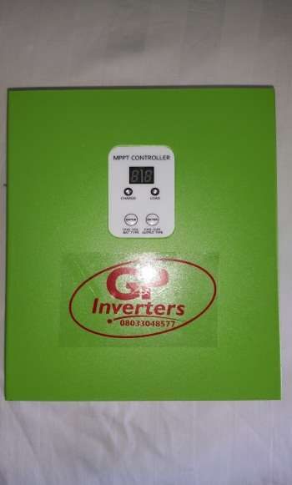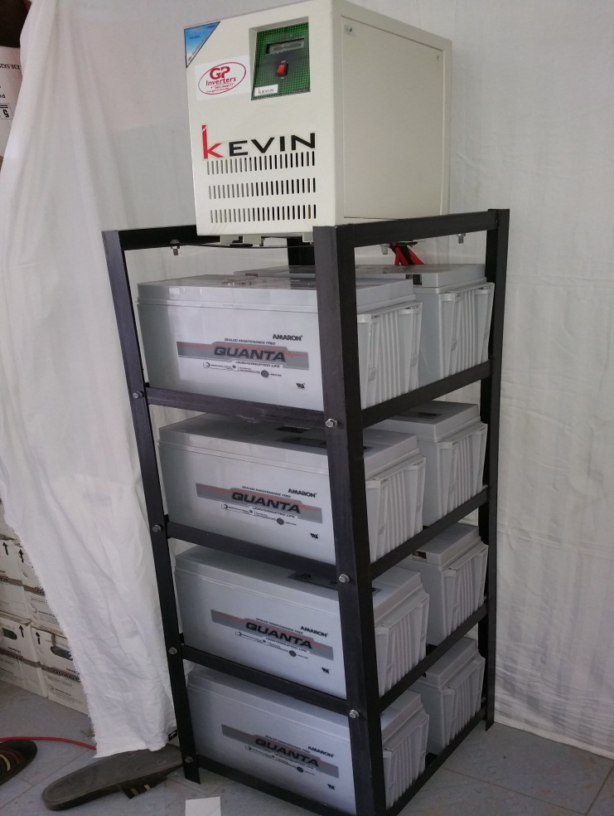

**3.5Kva 8 batteries hybrid with MPPT charge controller and 16 x 130w Solar Panels**

**Runs 18-24 hours on average loads**

**Load**

**Freezer Tv fans light points etc**

